Dear Parents/ Guardians,
We are thrilled to have your child in our new early learning program and look forward to getting to know you and your child personally. Together, we’ll form a productive relationship/partnership to ensure your child achieves his or her highest potential and all of his or her learning and/or development goals. We are looking forward to a year filled with challenges and excitement. The following outline is to help you understand what your child will be focusing on throughout the school year. We will focus on the following areas:
• Cognitive and General Knowledge Development – How they think and problem solve?
• Social- Emotional Development – How they self-regulate and relate to other?
• Physical Well- Being and Motor Development – How they use tools and the world around them to learn?
• Language and Literacy- How they communicate their knowledge through reading, writing, and oral language?
In order to support your child’s learning experience and development, please adhere to the times provided:
- Morning care 7:00 – 8:00 am
- Arrivals/ Breakfast 8:00 – 8:30 am
- Dismissals 3:00 – 3:30 pm
- Aftercare 3:30 – 6:00 pm
After 6 pm, there will be a mandatory late fee of $5 every minute, which is due during pickup. If the child(ren) are not picked up by 6:30pm, we will contact the authorities for further action.
If you have any questions about these items please don’t hesitate to ask! In addition, if you have questions or concerns email at openmindsacademyllc@gmail.com. We will update more contact information when available.
Let’s work together to make this the best learning experience your child!

Sincerely,
OMA
Parent/Guardian Information
Registration Date: ___ /__________/_______

Mother/Guardian
First Name: __________________________ M.I. ______ Last Name: ___________________________
Address: ____________________________________________________
Occupation: ________________________________ Home Phone: ( ) _______________________
Employer: __________________________________ Office Phone: ( ) _______________________
Work Address: ______________________________ Cell Phone: ( ) __________________________
[ ] Custodial Parent (If married, mark both parents) Mother’s SS#: _________________________
Email: ____________________________________ Driver’s License #: _________________________
Preferred PIN number for checking in/out (4 digits, numbers only) 1st choice __ __ __ __ 2nd Choice __ __ __ __
Marital Status:[ ] Married [ ] Single [ ] Divorced [ ] Separated [ ] Widowed [ ] Other_____________________
Father/Guardian
First Name: ______________________________ M.I. ______ Last Name: _______________________
Address: __________________________________________________________
Occupation: ________________________________ Home Phone: ( ) ________________________
Employer: _________________________________ Office Phone: ( ) _______________________
Work Address:________________________________ Cell Phone: ( ) ________________________

[ ] Custodial Parent (If married, mark both parents) Father’s SS#: ___________________________
Email: ______________________________________ Driver’s License #: ________________________
Preferred PIN number for checking in/out (4 digits, numbers only) 1st choice __ __ __ __ 2nd Choice __ __ __ __
Marital Status:[ ] Married [ ] Single [ ] Divorced [ ] Separated [ ] Widowed [ ] Other_____________________

Child Information
1st Child
First Name: ___________________________ M.I. ___ Last Name: _____________________
Child’s Nickname : _______________________ Age: __________________
Child’s Address: ______________________________________________________________
Gender: [ ] Male [ ] Female Date of Birth: _________________
Child’s S.S. #: ______________________________
List any existing medical conditions, medication and/or special attention your child may require?
_________________________________________________________________________
Allergies: __________________________________________________________________
Pediatrician’s Name: ___________________________ Phone: ( ) ___________________
Address: ____________________________________________________________________
2nd Child
First Name: ___________________________ M.I. ___ Last Name: _____________________
Child’s Nickname : _______________________ Age: __________________
Child’s Address: ______________________________________________________________
Gender: [ ] Male [ ] Female Date of Birth: _________________
Child’s S.S. #: ______________________________
List any existing medical conditions, medication and/or special attention your child may require?
_________________________________________________________________________
Allergies: __________________________________________________________________
Pediatrician’s Name: ___________________________ Phone: ( ) ___________________
Address: ____________________________________________________________________
3rd Child
First Name: ___________________________ M.I. ___ Last Name: _____________________
Child’s Nickname : _______________________ Age: __________________
Child’s Address: ______________________________________________________________
Gender: [ ] Male [ ] Female Date of Birth: _________________
Child’s S.S. #: ______________________________
List any existing medical conditions, medication and/or special attention your child may require?
_________________________________________________________________________
Allergies: __________________________________________________________________
Pediatrician’s Name: ___________________________ Phone: ( ) ___________________
Address: ____________________________________________________________________

Emergency Contacts & Authorized Pickup Persons

1st Contact/Pick Up
Name: ___________________________________________ Phone: _________________
Relationship to the Child: __________________________PIN for check in/out (4 digits, numbers only) __ __ __ __
[ ] Able to pick up child(ren) in the family
[ ] Not able to pick up the following child(ren): ____________________________________

2nd Contact/ Pick Up
Name: ___________________________________________ Phone: _________________
Relationship to the Child: __________________________PIN for check in/out (4 digits, numbers only) __ __ __ __
[ ] Able to pick up child(ren) in the family
[ ] Not able to pick up the following child(ren): ____________________________________

3rd Contact/Pick Up
Name: ___________________________________________ Phone: _________________
Relationship to the Child: __________________________PIN for check in/out (4 digits, numbers only) __ __ __ __
[ ] Able to pick up child(ren) in the family
[ ] Not able to pick up the following child(ren): ____________________________________

4th Contact/ Pick up
Name: ___________________________________________ Phone: _________________
Relationship to the Child: __________________________PIN for check in/out (4 digits, numbers only) __ __ __ __
[ ] Able to pick up child(ren) in the family
[ ] Not able to pick up the following child(ren): ____________________________________
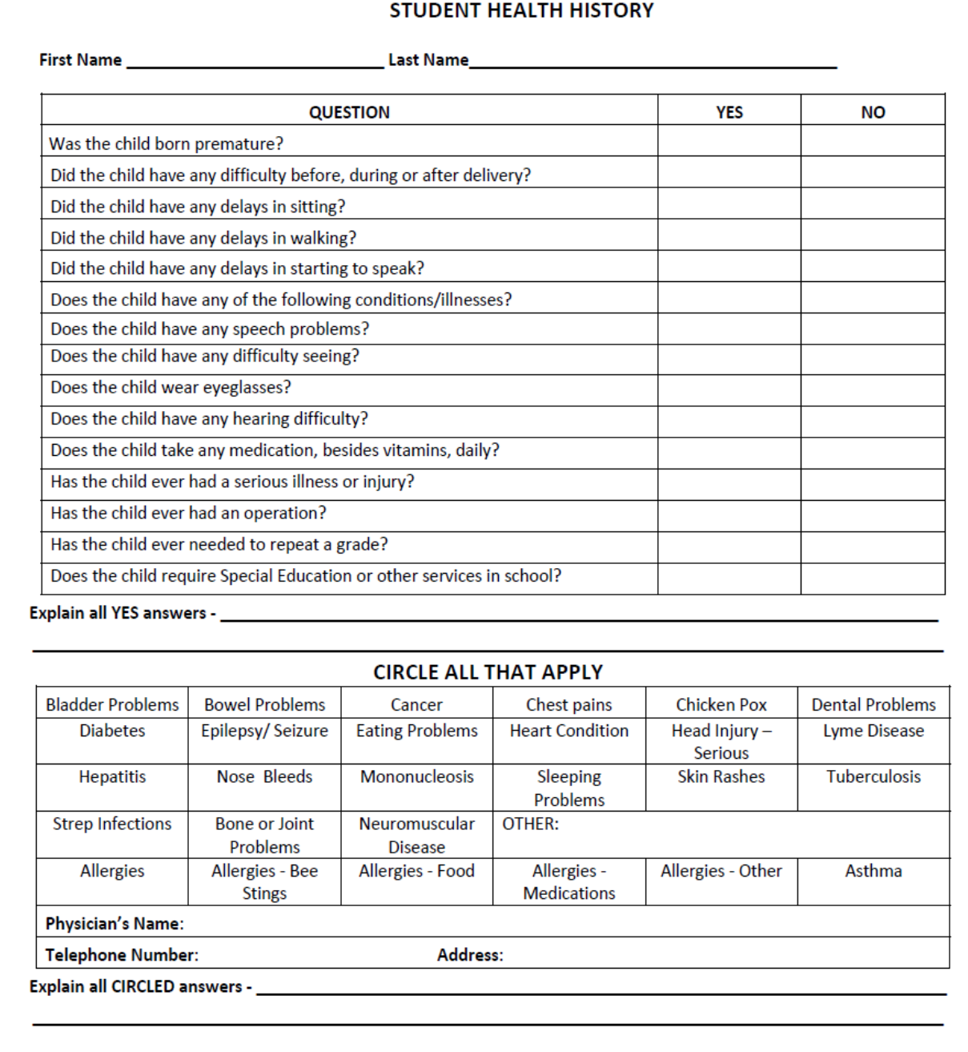
Please note: A complete Immunization Records copy must be on file prior to your child’s first day of enrollment.
Enrollment Agreement
Financial Binding Contract

- General Authorization.
We hereby grant Open Minds Academy permission for the child/children named on the registration packet to take part in all program activities including the use of all indoor and outdoor equipment; be photographed or videotaped in connection of OMA activities; a week in advance notice of field trip activities, and participate in water activities on site.
Mother/Guardian Signature __________________________ Date _____________
Father/Guardian Signature __________________________ Date _____________

- Hours.
Hours of operation of the facility are from 7:00 am to 6:00 pm Monday through Friday. A late of $5 a minute will apply after 6:00 pm. The fee is due upon pickup. If the no one picks up the child by 6:30 pm, the authorities will be contacted.

- Holidays.
We will be closed on the following days:

New Years Eve
New Years Day
Good Friday
Monday after Easter
Memorial Day
Labor Day
Day before Thanksgiving
Thanksgiving Day
Day after Thanksgiving
Christmas Eve
Christmas Day
Martin Luther King Day
Mardi Gras Day
Day after Mardi Gras
July 4th

In the event of an emergency of center closing, parents/guardians will be contacted immediately. No dicount from tuition will made for holidays or other days on which the facility does not open.

- Enrollment Policy.
Initial and continued enrollment will be at the discretion of Open Minds Academy based upon the best interests of the child, the expectation that he/she will benefit from the center’s program, and the welfare of other children enrolled. OMA does not discriminate regards of race, sex, creed, or origin.

- Uniforms.
The parent/ guardians agrees to supply uniforms garments for the child/children list in the registration packet. Child/Children are to wear uniform shirt with blue or black pants. Shoes must have toes enclosed along with the back of the heels. Tennis shoes are a perfect example.

- Lunch.
Lunch is provided by Open Minds Academy. We are a peanut free environment. Healthy food and snacks are provided daily, however, if your child/children need specific food such as, vegan, etc. Please send your child with their lunch and snack.

- Annual Registration and Supply Fee.
Parent/ Guardian agree to pay a non-refundable fee of $50 for registration. I understand that this registration covers the current year from August through May.
Parent/ Guardian agree to pay a non-refundable supply fee of $75 for child’s/ children’s supplies for two semesters. The first $75 is due upon registration for supplies from August to December. The second $75 is due in the first week in January to cover supplies from January to May. The supplies fee covers all classroom supplies such as wipes, towels, crayons, pencils, construction paper, scissors, stamps, stickers, books, activities, etc. The only items the parents/guardians will provide are diapers and formula (infants), pull-ups (Toddlers), back packs, and nap mat with blanket.

- Tuition.
The parent/guardian agrees to pay tuition fees, by the 1st of each month. Weekly tuition is due on MONDAY morning at the time of drop off. If the center is closed on Monday, the money will be due the very next day, Tuesday. If your child is absent on Monday for any reason on Monday (other than the center being closed), will be charged a late fee of $15 plus tuition. Absences are not deducted from the rate.

Tuition Chart
 | Weekly Rate | Monthly Rate | Discount 5 Week Monthly Rate
Infants – 24 months | $170 | $680 | $750 (save $100)
25 months – 5 years | $160 | $640 | $700 (save $100)

Siblings discount is $15 off weekly lowest rate between the two for immediate family members. Also, discount provided for military families, first responders, hospital personnel, and educators with 15% off the rate.
- Vacation Credit.
A vacation credit is offered if your child/ children have been enrolled for 6 months. You must submit a request three weeks in advance, to receive a week of no tuition pay. One vacation credit is allowed per school year.

- Withdrawal.
Full payment of tuition and other fees will continue until the date indicated by the parent or guardian as the date of withdrawal. The parents/guardians must give a written letter three weeks in advance of such withdrawal date. I understand that any items belonging to my child that are left at Open Minds Academy will not be given to me nor any tax information will be released to me, unless all outstanding balances have been paid in full.

“I, (print name) ____________________________________, specifically reviewed the Enrollment Binding Contract from A through J and hereby agree to comply with all provisions hereof. I understand if I fail my finance agreement obligations that my account will be turned over to a collection agency or small claims court for collections.”

Parent/Guardian Signature ______________________________Date ___________________

OMA Staff Member ___________________________________ Date ___________________

